

SYLLABUS
College of the Arts

School of Art and Design

ARH 3830: History of Comics, Cartoons, and Animation

Spring 2026

Course Information

Modality: Hybrid
Class Meeting Time: Section 01: Monday & Wednesday, In Person, 9:05am-9:55am
Section 02: Monday & Wednesday, In Person, 10:10am-11:00am
Friday: Online Asynchronous
Location: Academic Learning Center 2110
Link to D2L Class Site:

Instructor Information

Name: Colin Wheeler
Email: cwheel46@kennesaw.edu
Office Hours: By appointment only
Preferred method of communication: Email

Course Description

Prerequisites: ARH 2850
Credit Hours: 3
This lecture course will examine the historical development of comics, cartoons, and animation in global culture, tracing their evolution against the background of social, cultural, and technological changes from the 17th to the 21st centuries. Topics may include the subsequent emergence of various related art forms such as animated cartoons and graphic novels.

Course Materials

REQUIRED TEXTS
Furniss, Maureen. A New History of Animation. New York: Thames & Hudson, 2016.
BOOK NOTES
This is a DAY ONE ACCESS course material item. These materials will be accessible to students on the first day of classes via D2L Brightspace, KSU's Learning Management System (LMS). The cost of these materials will be billed to students student account. Students will receive an email from no-reply@verbasoftware.com , one week before classes start, containing information on how much student’s materials are as well as how to Opt-Out of this program. Students will receive subsequent emails with this information on the first day of class and the day before to opt out. By Opting-Out, students will be refunded and will lose access to these digital materials and must purchase them elsewhere.
RECOMMENDED TEXTS
See Recommended Reading section on D2L
TECHNOLOGY REQUIREMENT
Students must bring a laptop or tablet to class on days that require taking a quiz or exam. Students can check out laptops at the school library.
LOCKDOWN BROWSER REQUIREMENT
This course requires the use of LockDown Browser for online exams. LockDown Browser will prevent students from accessing other websites or applications; one will be unable to exit the test until all questions are completed and submitted. Watch this video to get a basic understanding of LockDown Browser:https://web.respondus.com/lockdownbrowser-student-video/

Course Learning Outcomes

- Define technical processes and jargon related to the media
- Explain the contribution of key figures and the impact of their innovations.
- Delineate broad eras in media history and identify the social forces that cause these transitions
- Emulate the styles and techniques of master animators and comic artists
Course Requirements and Assignments

ASSIGNMENT | DUE | Value
Attendance | N/A | 50 points
Mini-Quizzes | Varies | 100 points
Midterm | 2/23 | 50 points
Masters Study 1 Rough | 3/4 | 25 points
Masters Study 1 Final | 4/1 | 100 points
Masters Study 2 Rough | 4/22 | 25 points
Final Exam | 5/10 | 50 points
Masters Study 2 Final | 5/11 | 100 points
TOTAL |  | 500 points

ATTENDANCE - 50 Points
See Course Policies

MINI-QUIZZES- 100 Points (10 points each)
There will be a number of short mini-quizzes following the week’s reading and viewing. They consist of multiple choice questions on D2L. Each quiz becomes available on Monday and closes Sunday. Students may take the quiz up to three times, only the highest score is counted towards the final grade. These quizzes are open-note. The lowest scoring quiz will be dropped from the final grade.

MIDTERM + FINAL EXAMS - 100 Points (50 points each)
Like the quizzes, there will be a midterm and final that consist of multiple choice questions on d2l. They also require the lock-down browser but are open-note. Unlike the mini-quizzes, they are cumulative and may only be taken once.

MASTERS STUDIES - 250 Points (125 points each)
Before beginning, it is imperative students carefully review the rubric for this assignment. Students will be expected to complete two masters studies over the course of the semester, in which one will select either an animator or a sequential artist from a list to create either a 3-5 second animated short (.mp4 or .mov) or 3-5 page comic (.pdf) in that artist’s style. Additionally, the study should include a short paper (500-1000 words, .doc) describing how the artist’s work informed the project and an assessment of how one did in mimicking their style. The rough draft is worth 20% of the total assignment’s score and should consist of the animation or comic fully sketched out and a paper outline in bullet points with a bibliography referencing at least three of the artist’s works, along with functioning links/page numbers.

Evaluation and Grading Policies

Grades will be tabulated on a point system. Assignments and quizzes/exams will add up to 100 possible points for the semester, not counting extra credit. I will round up grades if they are > or = .5 or above, for example, an 89.6 is an A, but 79.2 is a C.

A = 89.50-100.00 total semester points
B = 79.50-89.49 total semester points
C = 69.50-79.49 total semester points
D = 59.50-69.49 total semester points
F = 59.49 or below total semester points

EARLY ALERTS/PROGRESS REPORT
This class is participating in Early Alerts, which faculty will submit during the first few weeks of class. These reports notify advisors and student success coaches to a range of things like missing class, missing assignments, if students might need to visit tutoring, or could benefit from help with time management or study skills. These are not recorded as grades and are meant to provide students with some additional resources to ensure students can be successful in their class. If students receive notification of an early alert, please take advantage of these resources.

RUBRICS
Rubrics for assignments can be found under the “Rubrics” folder on the D2L page. Please take a moment to review the rubric before starting the project.

HOW DO I GET AN A?
Maintain an average of 89.5 or more by attending the lectures, take notes, and stay up to date on the reading. Procrastination is perilous, try to get one’s work done early and ask for evaluation. Carefully review the rubric before beginning an assignment. Push oneself to go beyond the material of this class and find an artist whose style one is comfortable mimicking. If students are running late or going to miss class, email the professor before class begins explaining the situation. Students may request an extension by submitting what one has and leaving a comment under the project requesting more time. If students make this request before the deadline has elapsed, a 48-hour extension will be given.

Course Policies
ATTENDANCE POLICY
Arrive to class on time and participate in discussions to receive full credit. Students who arrive after the professor has taken attendance lose 2.5 points, while missing a class drops the attendance score by 10 points. When a student misses more than 6 classes, they may be consulted to withdraw from the course by the respective instructor and will receive a “W” based on the Kennesaw State University grading policy, if the deadline to do so has not passed (see Schedule section of this syllabus).
Absences may be forgiven if notice is provided prior to the beginning of class, according to the professor’s discretion. Otherwise, it can only be reversed if substantial proof from a medical professional or similar documentation (doctor’s note, police report, letter from the Dean of Students, notice of jury duty summons, etcetera.) is presented the following class period or in a timely fashion via email. Absences for any other reason will not be excused. The final score for attendance is applied at the end of the semester.
INSTRUCTIONAL CONTINUITY PLAN
Kennesaw State University (KSU) may decide to close campuses, operate on a delayed schedule, or transition to remote instruction for inclement weather or in case of emergency.
The University will announce campus closures, delayed schedules, or remote instruction through KSU Alerts sent to the student’s cell number on file and to student’s university email account. In addition, announcements will be posted on KSU’s home page: www.kennesaw.edu.
Our class continuity plan includes:
- Communication: Please check D2l Brightspace or e-mail for necessary instructions.
- Virtual Classes: If in-person classes are not possible, we may transition to virtual classes using MS Teams.
- Assignments and Assessments: Deadlines for assignments and assessments may be adjusted to accommodate the emergency situation.
We understand that emergencies create unique challenges. If students need additional support during an emergency, reach out via Brightspace or e-mail. The university also offers resources such as counseling and academic support, which can be accessed remotely.
CLASS ENVIRONMENT
The classroom is a sacred space, like a monastery or a movie theater. The professor withholds the right to dismiss students who are loud or distracting in class.
SNACKS
Snacks in class must be quiet and odorless. Please be considerate of other students and potential food borne allergies. Beverages must have lids.
TECHNOLOGY
Turn off cell phones, and silence one’s tablet or computer. I withhold the right to confiscate devices that persistently make noises in class. No headphones are permitted.
LATE ASSIGNMENT POLICY
All assignments are due at 11:59pm on the date assigned. For all assignments, a 48-hour extension may be granted upon request, if students leave a note in the assignment on D2L prior to the deadline. Late assignments/exams will be accepted without penalty if students have: (a) the permission of the instructor/dean of students beforehand; (b) jury duty notice; or (c) a doctor’s note. Otherwise… they lose one letter grade if the assignment is submitted less than 24 hours after the due date. They then lose another letter grade per day after the due date has elapsed. Assignments over one week late will not be accepted. Projects submitted in the wrong format or cannot be opened will be marked late. Not receiving an email response is not an excuse for submitting late. Missed exams will need to be taken at the testing center if the student has a doctor’s note, jury duty notice, or a letter from the dean of students; please note they charge $30.00 per session. Make-up exams must be completed in person.
SUBMISSIONS
Papers must be submitted as .doc or .docx word documents. The Final Presentation may be a .pdf, .ppt, or .pptx file. All assignments must be submitted through D2l, those sent through email will not be graded. Always double check that one’s file is viewable after submission.
POLICY ON THE USAGE OF ARTIFICIAL INTELLIGENCE
Students are expected to generate their own work in this class. When one submits any kind of work, one is asserting that they have created it completely on their own unless one indicates otherwise using quotation marks and proper citation for the source(s) one used. Submitting content that has been generated by someone other than oneself, or that was created or assisted by an AI generative tool is cheating and constitutes a violation of the KSU Code of Academic Integrity. Students using AI generative tools will be reported to the Department of Student Conduct and Academic Integrity.
PLAGIARISM
The verb plagiarize is defined as “to steal and pass off (the ideas or words of another) as one’s own.” Every assignment submitted must contain one’s original ideas, not words written by a machine or another author. Students should always give credit to all original authors for direct quotations and ideas summarized or paraphrased, and artists and filmmakers for referred images or graphics. Students must present their own original ideas alongside the ideas of other authors and artists without distorting their meaning, while including in text citations and a works cited section. Assignments without citations will receive a score of 0, although students may resubmit it provided all work was free of plagiarism, although late penalties still apply. Students caught plagiarizing will be reported to the Department of Student Conduct and Academic Integrity.
GRADE CHANGES
Assignments may be regraded as needed. I begin the semester giving every student the benefit of the doubt. If I come across evidence of plagiarism or cheating, that benefit is lost, and I will go back through previous assignments to check.
OFFICE HOURS
Students may request meetings over Microsoft Teams.
DESIRE2LEARN
On D2L, students will find the syllabus, announcements, and quizzes/exams. Additional, supplemental readings will be posted on our course site. Up-to-date grades are also posted there. Get familiar with using D2L, if students have any questions, contact Technical Support Services.
FEEDBACK
Please allow up to 72 hours to respond to email.
UNFORESEEABLE CIRCUMSTANCES
The instructor reserves the right to alter course requirements should the need arise. This includes changing due dates, modifying policies if necessary, etc. It rarely happens, but sometimes unforeseeable circumstances demand adaptation.
KSU WRITING CENTER
Students are strongly encouraged to take advantage of the KSU Writing Center, a free resource to help one improve any kind of writing in any subject. Visit writingcenter.kennesaw.edu to reserve one’s appointment and to learn more about Writing Center services and online resources.

Department or College Policies

NON-GRADE APPEAL GRIEVANCE GUIDELINES FOR STUDENTS (KSU Student Handbook)
(https://www.kennesaw.edu/complaintsappeals.php)

STUDENT GRIEVANCES
In accordance with the Undergraduate Catalog, issues with an instructor or a course should first be addressed directly with the instructor. If the issue cannot be resolved, the student should report to the Assistant Director of the School of Art and Design, and subsequently to the Director. If still not resolved, the student can appeal to the Dean of the College of the Arts. No grievance may be considered that does not follow this process, and no levels of appeal may be skipped.

GRADE APPEALS
Grade Appeals have their own process, as described in the undergraduate catalog. There is also an online resource on the Grade Appeal Process on the Registrar section of the KSU website:
Grade Appeal Process Web page

SOAAD PRINT LAB (VA 208):
Deposit KCash into one’s accounts in order to use the School of Art and Design’s Print Services. Students can refill their KCash funds at a KCash machine or by logging into the KCash Account Manager.

Please see SOAAD website for new printing services, pricing, hours, and scheduling.

PHOTO CONSENT AND RELEASE FORM (QR Code included):  Students must sign a Photo Consent and Release form in order to have their likeness and work displayed as part of social media or other publicly viewable content as it relates to the School of Art and Design. The professor might provide and then collect a Photo Consent and Release form in class as part of these efforts to promote one’s work and the class. Students can decline to sign the form and as such neither one’s likeness nor work will be considered or used in any said social media or other publicly viewable content. | 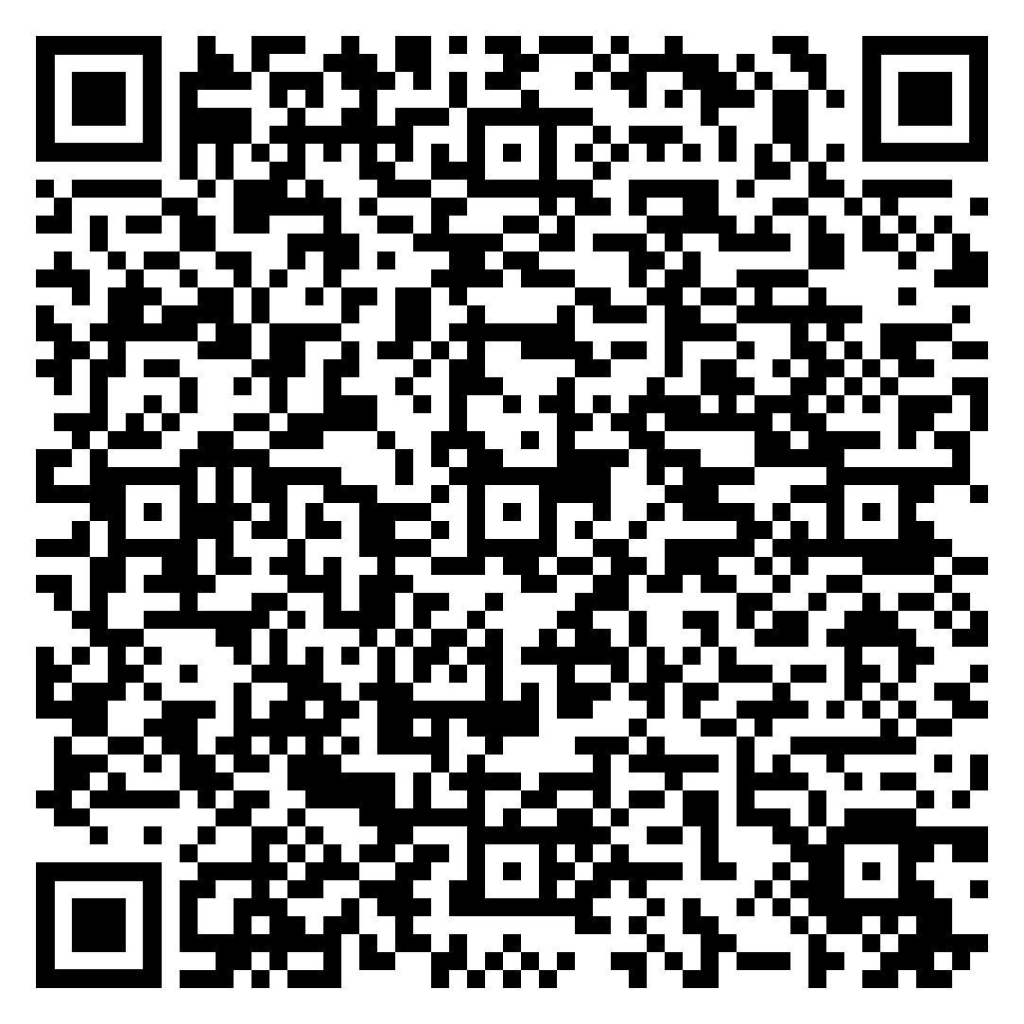

Institutional Syllabus Policies, Procedures, and Resources

Federal, BOR, & KSU Required Syllabus Policies and Student Resources

Course Schedule:

Class | Dates | Reading |  | Topic | Due
Week 1
1 | 1/12 |  |  | Setting the Scene for Animation
2 | 1/14 |  |  | The Magic of Early Cinema
Week 2
3 | 1/19 |  |  | No Class | Syllabus Quiz
4 | 1/21 |  |  | Comics in the Era of ‘‘Yellow Journalism’
Week 3
 | 1/26 | 3. Foundations of the Animation Industry |  | Beginning the Animation Industry | Mini-Quiz 1
5 | 1/28 |  |  | Emergence of the studio system
Week 4
6 | 2/2 | 4. Late Silent Era and the Coming of Sound |  | Icons of the Jazz Age | Mini-Quiz 2
7 | 2/4 |  |  | The Superhero and the Comic Book
Week 5
8 | 2/9 | 5. Animation as Modern Art |  | European experimentation | Mini-Quiz 3
9 | 2/11 |  |  | Figures of the avant-garde
Week 6
10 | 2/16 | 7. Style and Fleischer Studio and 8.Comedy and the Dominance of American Animation |  | Fleischer vs. Disney | Mini-Quiz 4
11 | 2/18 |  |  | MGM and Warner Brothers
Week 7
12 | 2/23 | 9. Animation in World War II |  | Animation at War | Midterm
13 | 2/25 |  |  | Graphic Narratives in Asia
Week 8
14 | 3/2 | 10. Intrntl. Developments in Postwar Animation |  | Capitalism vs. Collectivism | Mini-Quiz 5
15 | 3/4 |  |  | A third way: India and Canada | Master’s Study 1 (Rough)
Spring Break
 | 3/9 |  |  | No Class
 | 3/11 |  |  | No Class
Week 9
16 | 3/16 | 12. Midcentury Shifts in American Design |  | UPA and Midcentury Modern | Mini-Quiz 6
17 | 3/18 |  |  | Mainstream American Comics Post-World War II
Week 10
18 | 3/23 | 13. Early Television Animation |  | Early Television | Mini-Quiz 7
19 | 3/25 |  |  | The Toyetic Era
Week 11
20 | 3/30 | 15. New Audiences for Animated Features |  | Disney’s dark age, new competition | Mini-Quiz 8
21 | 4/1 |  |  | The Return of Graphic Narratives for Adults | Master’s Study 1 (Final)
4/3: Last Day to Withdraw to Receive a W Grade, 11:45 p.m.
Week 12
22 | 4/6 | 17. Voices from the Eastern Bloc | ` | Russian and Czech animation | Mini-Quiz 9
23 | 4/8 |  |  | No Class
Week 13
24 | 4/13 | 22. The Culture of Japanese Animation |  | Manga | Mini-Quiz 10
25 | 4/15 |  |  | Anime
Week 14
26 | 4/20 | 20. Television as a Creative Space |  | MTV and Nickelodeon | Mini-Quiz 11
27 | 4/22 |  |  | Cartoon Network, Comedy Central | Master’s Study 2 (Rough)
Week 15
28 | 4/27 | 21. Computer-Generated Animation in Features |  | CGI special effects | Mini-Quiz 12
29 | 4/29 |  |  | Pixar, Dreamworks, Illumination
Week 16
30 | 5/4 |  |  | Web Comics
 | 5/6 |  |  | No Class
Week 17
 | 5/11 |  |  | No Class | Master’s Study 2 (Final)  Final Exam

Merriam-Webster. “Definition of PLAGIARIZING.” Merriam-Webster.com, 2019, www.merriam-webster.com/dictionary/plagiarizing.

